The line below shows the velocity of Cart A that crashed into Cart B.
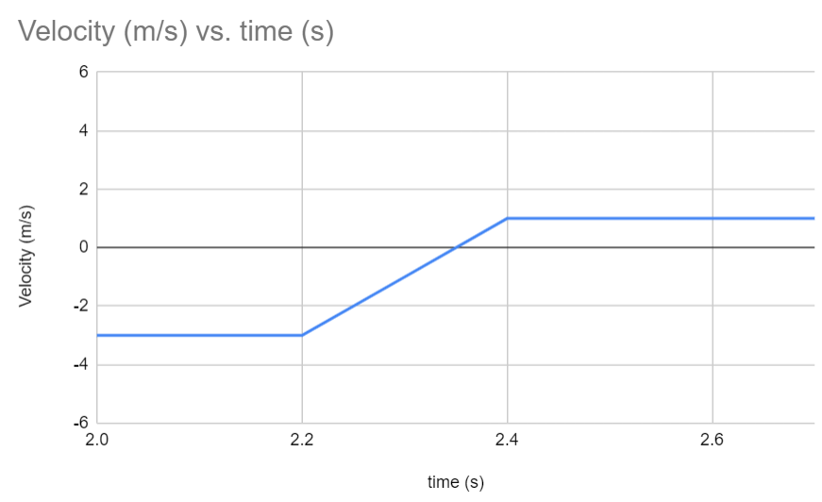
- (1 pt) Which way is Cart A originally moving?

- (2 pts) How is Cart A moving after the collision? (describe both speed and direction)

- (2 pts) How much did Cart A’s velocity change by? Show calculations.

- (2 pts) Cart A has a mass of 0.2kg. Cart B has a mass of 0.4kg. Cart B was originally not moving. Draw what Cart B’s velocity vs time would look like on the above graph.

- (3 pts) Describe your method for drawing the line. How did you know what velocities to choose, and when to change the velocity number?

